小伙伴们好，请大家计算Jaccard Index。

算法为The Jaccard Index or Jaccard similarity coefficient is calculated by s/( u1 + u2 + s), where s is the number of items two questionnaires share, and u1 and u2 the number of items that are unique to each of the two scales.

实际就是s=两个量表相同的症状数，u1和u2=两个量表总症状数-s

例如：

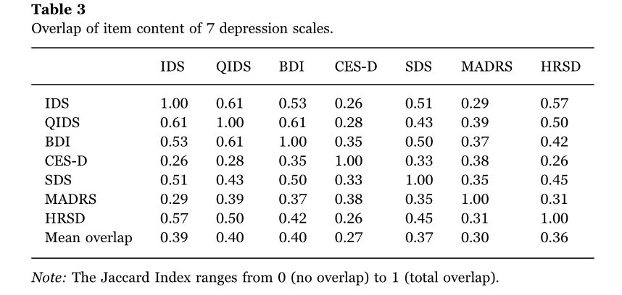

Ids和qids根据补充材料，相同的症状数（即同时编码为1）是20个，ids的总症状数是33个，qids的总症状是20个。

所以结果就是20/(33-20+20-20+20)=20/33

同理，bdi和cesd的值就是，12/(25-21+21-12+12)=0.35

|  |  |  |  |  |  |  |
| --- | --- | --- | --- | --- | --- | --- |
| **Matrix B (used for Jaccard index analyses)** | | | | | |  |
| 1: symptoms featured in scale in some way | | | | |  |  |
| 0: symptom not featured in scale | | | |  |  |  |
| red: idionsyncratic symptoms | | | |  |  |  |
|  |  |  |  |  |  |  |
| **IDS30** | **QIDS16** | **BDI** | **CESD** | **SDS** | **MADRS** | **HRSD** |
| 1 | 1 | 1 | 1 | 1 | 1 | 1 |
| 1 | 1 | 1 | 1 | 1 | 1 | 1 |
| 1 | 1 | 1 | 1 | 1 | 1 | 1 |
| 1 | 1 | 1 | 0 | 0 | 0 | 0 |
| 1 | 1 | 1 | 1 | 1 | 1 | 1 |
| 1 | 0 | 0 | 1 | 0 | 0 | 1 |
| 1 | 0 | 0 | 0 | 0 | 0 | 1 |
| 1 | 0 | 1 | 0 | 1 | 0 | 1 |
| **1** | 0 | 0 | 0 | 0 | 0 | 0 |
| **1** | 0 | 0 | 0 | 1 | 0 | 0 |
| **1** | 0 | 0 | 0 | 0 | 0 | 0 |
| 1 | 1 | 1 | 1 | 1 | 1 | 1 |
| 1 | 1 | 1 | 0 | 1 | 0 | 0 |
| 1 | 1 | 0 | 0 | 1 | 0 | 1 |
| 1 | 1 | 0 | 0 | 0 | 0 | 0 |
| 1 | 1 | 1 | 1 | 1 | 1 | 0 |
| 1 | 1 | 1 | 0 | 1 | 0 | 0 |
| 1 | 1 | 1 | 0 | 0 | 0 | 1 |
| 1 | 1 | 1 | 0 | 0 | 0 | 0 |
| 1 | 0 | 1 | 1 | 1 | 1 | 0 |
| 1 | 1 | 1 | 0 | 1 | 1 | 1 |
| 1 | 1 | 1 | 0 | 0 | 0 | 1 |
| 1 | 1 | 1 | 1 | 1 | 0 | 1 |
| 1 | 1 | 1 | 1 | 1 | 1 | 1 |
| 1 | 1 | 1 | 1 | 0 | 1 | 1 |
| 1 | 0 | 1 | 0 | 1 | 0 | 1 |
| 1 | 1 | 0 | 0 | 0 | 0 | 1 |
| 1 | 1 | 1 | 0 | 1 | 0 | 1 |
| **1** | 0 | 0 | 0 | 0 | 0 | 0 |
| 1 | 0 | 0 | 0 | 1 | 0 | 1 |
| 1 | 0 | 0 | 0 | 1 | 0 | 1 |
| **1** | 0 | 0 | 0 | 0 | 0 | 0 |
| **1** | 0 | 0 | 0 | 0 | 0 | 0 |
| 0 | 0 | 1 | 1 | 0 | 0 | 0 |
| 0 | 0 | **1** | 0 | 0 | 0 | 0 |
| 0 | 0 | **1** | 0 | 0 | 0 | 0 |
| 0 | 0 | **1** | 0 | 0 | 0 | 0 |
| 0 | 0 | 1 | 1 | 1 | 0 | 0 |
| 0 | 0 | 0 | **1** | 0 | 0 | 0 |
| 0 | 0 | 0 | 1 | 1 | 0 | 0 |
| 0 | 0 | 0 | **1** | 0 | 0 | 0 |
| 0 | 0 | 0 | **1** | 0 | 0 | 0 |
| 0 | 0 | 0 | **1** | 0 | 0 | 0 |
| 0 | 0 | 0 | **1** | 0 | 0 | 0 |
| 0 | 0 | 0 | **1** | 0 | 0 | 0 |
| 0 | 0 | 0 | **1** | 0 | 0 | 0 |
| 0 | 0 | 0 | 0 | **1** | 0 | 0 |
| 0 | 0 | 0 | 0 | **1** | 0 | 0 |
| 0 | 0 | 0 | 0 | 0 | **1** | 0 |
| 0 | 0 | 0 | 0 | 0 | **1** | 0 |
| 0 | 0 | 0 | 0 | 0 | 0 | **1** |
| 0 | 0 | 0 | 0 | 0 | 0 | **1** |
| 6 | 0 | 3 | 7 | 2 | 2 | 2 |
| 33 | 20 | 25 | 21 | 23 | 12 | 22 |
| 28 | 9 | 21 | 20 | 20 | 10 | 17 |
| 28 | 9 | 21 | 18 | 20 | 9 | 17 |
| 0.63 | 0.38 | 0.48 | 0.40 | 0.44 | 0.23 | 0.42 |
| **IDS30** | **QIDS16** | **BDI** | **CESD** | **SDS** | **MADRS** | **HRSD** |

附件表中的Symptom_table (2)是我模仿eiko做好的计算Jaccard Index和其他值的表，s值是我计算出的所有s值，但我不保证全对，所以希望大家计算后有不对的告诉我一下0.0，或者你可以想办法直接计算出Jaccard Index也希望你能分享在群里更快捷的办法。

Symptom_table (3)是我个人计算s值的办法，其中f列是计算两列同时为1的公式。我感觉比较笨，也欢迎大家分享更快捷的办法。

最终结果的格式大家也仿照s值的表即可。

汪浩远和田柳青负责完成

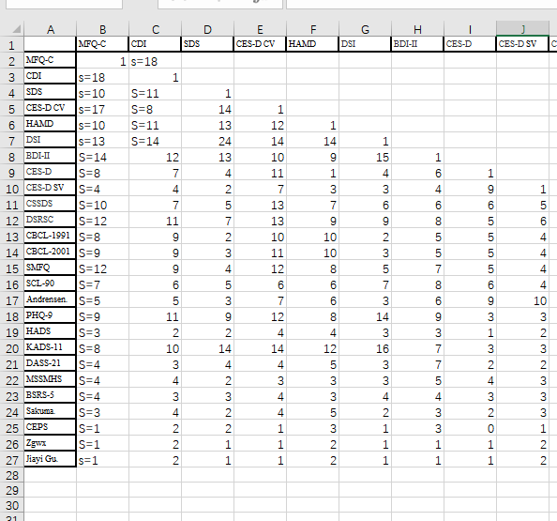

这个表a-j的部分

胡孟真和刘伟彪完成这个表

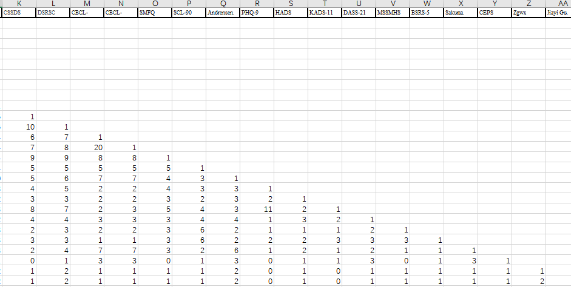k-最后，大家分头完成，之后各组二人核对结果保证无误。

请大家在下周二之前给我。

大家有问题可以随时联络我。